Self and Peer assessment form for COM109 Coursework 2

Please assess your contribution to the preparation of the solution to the COM109 coursework in relation to that of your other team member.

Did each of you contribute equally? If so, each team member will be given an equitable apportioning of the marks. For non-equitable efforts, those contributing less than their fair share will receive a scaled mark accordingly.

Allocate a mark for each member of your team. Ensure that the marks together total 100.

Group ID (eg: subGroupA):

Peer Contribution Evaluation

Group Member Name | Student ID | Estimated Contribution (%)
 |  | 25%
 |  | 25%
 |  | 25%
 |  | 25%
Total |  | 100%

What particular responsibility/tasks did each team member undertake during the preparation of the assignment solution?
completed: (1) Gallery and Reviews page; (2) responsive CSS; (3) reservation validation; (4) Cookie Consent Banner; (5) navigation fixes; and (6) GitHub maintenance.
completed: (1) reservation page; (2) responsive design; (3) booking JavaScript and localStorage; (4) confirmation and receipt features; (5) link fixes; and (6) testing and GitHub maintenance.
Jha completed: (1) Menu page; (2) responsive styling and filtering; (3) Admin Dashboard; (4) booking search and statistics; (5) CSV export; and (6) testing and GitHub maintenance.
completed: (1) Staff Portal Login; (2) shared style.css; (3) responsive CSS; (4) reusable utils.js; (5) resource and navigation fixes; and (6) testing and documentation, GitHub control.

Self-Assessment Checklist
Task | Yes / No
- Created HTML structure and web pages | Yes
- Styled the site using CSS (including responsiveness) | Yes
- Developed JavaScript functionality (animations, validation) | Yes
- Worked on form validation and user input handling | Yes
- Integrated accessibility features | Yes
- Managed version control (GitHub) | Yes
- Documented code and wrote report sections | Yes
- Debugged issues and tested functionalities | Yes
- Organised group meetings & coordinated tasks | Yes
- Packaged and submitted final assignment files | Yes

Repository Link: https://github.com/Satirtha7/Book-IT

Introduction
This report describes my individual contribution to The Golden Leaf Restaurant Website.The purpose of our website is to provide a modern and interactive restaurant platform where visitors can explore restaurant information, view the food menu, access gallery and review content, make reservations, and interact with additional website functionality.
I was mainly responsible for creating the Chef and Menu page - its HTML markup, CSS design and dynamic menu features. Besides that, I created the Staff/Admin Dashboard that has functionality to view search filter and manage reservations. In addition, I contributed to the main JavaScript application file by implementing navigation behaviour, mobile menu interaction, animation initialisation and the frontend AI receptionist interface.
Prior to programming, I identified two primary workflows - a guest browsing menu via phone and a staff member viewing reservation through computer. Categorising features helped me manage the 40+ menu items and I designed administrative dashboard with the sidebar, a block of statistical figures, bookings table that can be searched, export feature and other details. I took advantage of pre-existing style.css file for consistency and also created admin.css and menu-page.css for the site.

Description of HTML Code for the Chef and Menu Page
My primary frontend page is responsible for displaying the restaurant’s chef information and the interactive culinary menu.
The document begins with standard HTML5 structure and includes responsive viewport settings. I linked the project stylesheet together with the shared stylesheet and responsive stylesheet created by another group member. External resources such as Google Fonts, Font Awesome and AOS are also included to provide consistent typography, icons and scroll-based animation.
The page contains a navigation bar with links to the main website sections, including Home, About, Menu, Gallery, Reviews and the reservation page. I also included the mobile navigation button, which is controlled through JavaScript.
The first major section is the Chef section. It contains a chef image, heading, chef name, description and signature image. AOS attributes such as data-aos="fade-right" and data-aos="fade-left" are used to prepare the content for animated appearance when the user scrolls.
The second major section is the Menu section. Instead of manually writing every menu item into the HTML, I created a menu container with the ID menuGrid. The JavaScript file later inserts the menu items into this container. The page also includes filter buttons for All, Starters, Main Course, Breads, Rice, Desserts and Drinks. Each button contains a data-filter value that is used by menu.js to determine which items should be displayed.
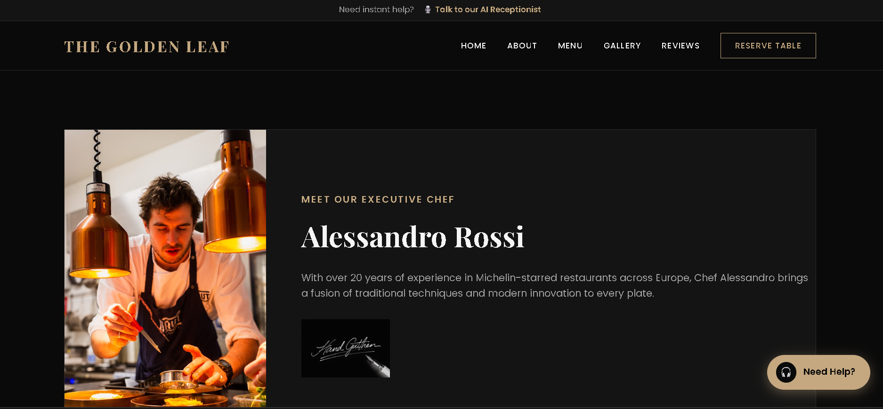
Figure 1: Chef and Menu page showing the chef information section.
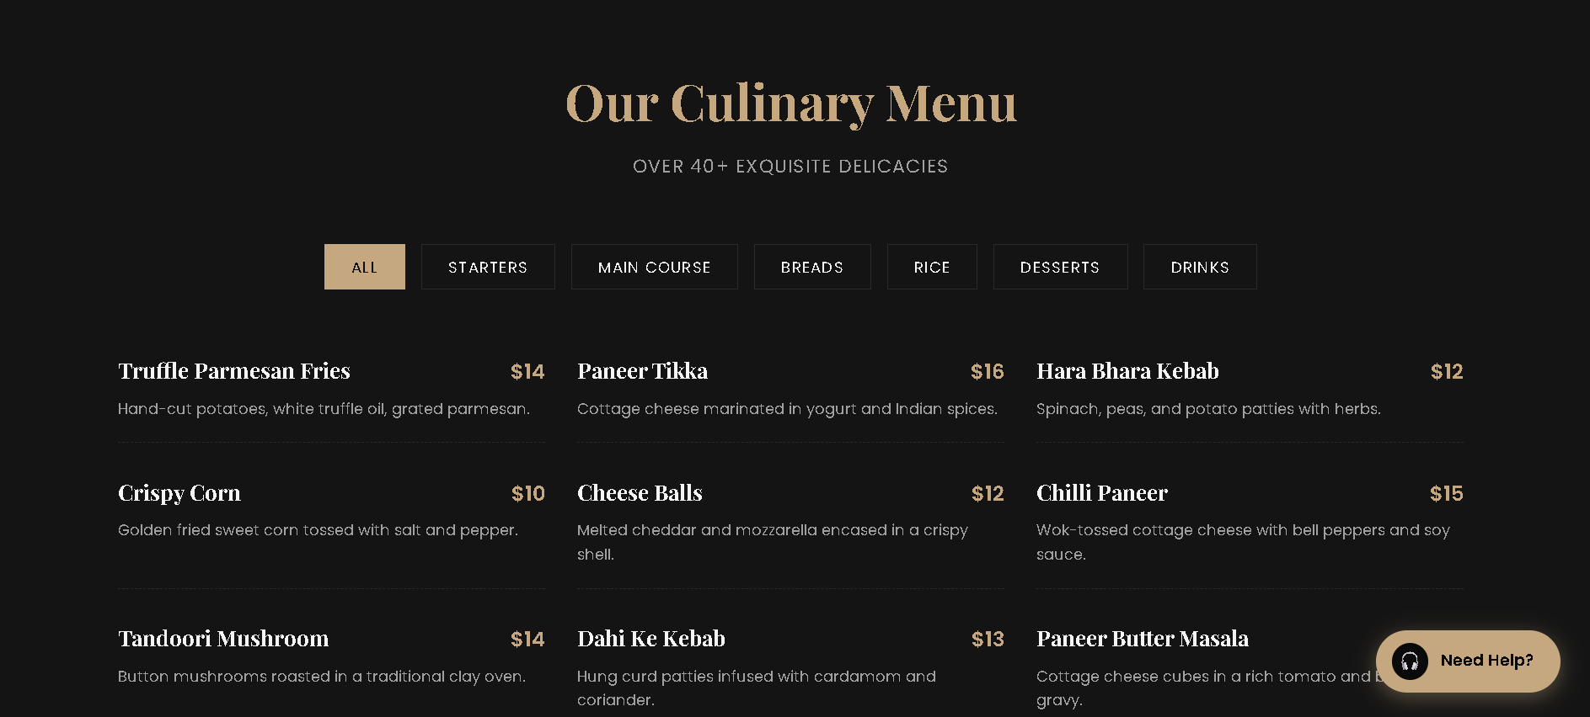
Figure 2: Menu page showing the category buttons and dynamically displayed menu items.

Description of CSS Code for the Chef and Menu Page
The visual design of my page is mainly controlled through style.css. I created separate styles for both the chef and menu sections while reusing the project’s existing colour variables, typography and design system. For. chef-section in the chef section, it gives the background as well as overall spacing whereas. chef-container through the use of Flexbox puts the chef image beside the information. The image, which is set in the container to take only a portion of its space but it covers itself using object-fit: cover property such that it looks appropriately inside the box. For the chef's headline, we have utilized the project font and larger typography creating a visually dominating heading. The supporting text uses an alternative, muted text color, the chef's subtitle uses the project main gold colour. All that together gives this section the look consistent with restaurant identity.
To style the menu section I have added styles such as.menu-section, menu-filters.filter-btn.menu-grid and menu-item. As for the menu grid, it makes a use of CSS Grid repeat(auto-fit, minmax(min(400px, 100%), 1fr)) that enables the number of columns to be flexible given the screen width.
The category buttons have got the borders and transition effects too as well as some spacing. Once a button has a pointer over it or it is clicked then the active state of the colour change takes over both bg and text. That makes the interaction of the user with the filtering controls clear and intuitive. Separating dashed lines have gone for the dynamically generated menu items. Flexbox positions the item name on one side and the price on the other so that they look aligned. I also added a fade-in animation to menu items once they're shown on screen.
The project also required consideration of different screen sizes. I therefore worked on responsive styling and made several mobile-related improvements, which are also visible in my Git history.
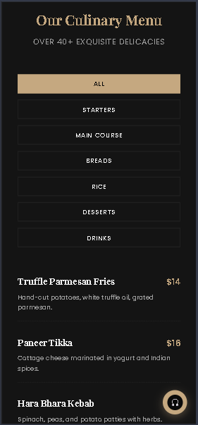
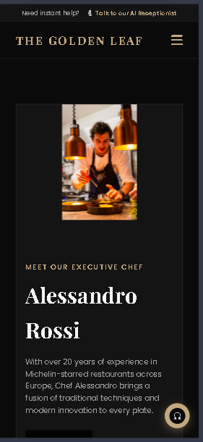
Figure 3: CSS-based responsive layout of the Chef and Menu page.

Description of JavaScript Code
The main dynamic menu functionality is contained in menu.js. I created a menuData array containing the menu information, including the name, price, category and description of each item.
When the DOM finishes loading, the script locates the menuGrid element and the filter buttons. The renderMenu() function clears the existing menu content and selects the appropriate items. If the selected category is all, the complete dataset is used; otherwise, JavaScript’s filter() method returns only the items belonging to the selected category.
For every selected item, the script creates a new <div> element and inserts the food name, price and description into it. These generated elements are then appended to the menu grid. This approach keeps the HTML cleaner and makes the menu content easier to update.
The filter buttons use event listeners. When a user clicks a category, the previous active class is removed, the selected button receives the active class, and renderMenu() is called again with the selected category.
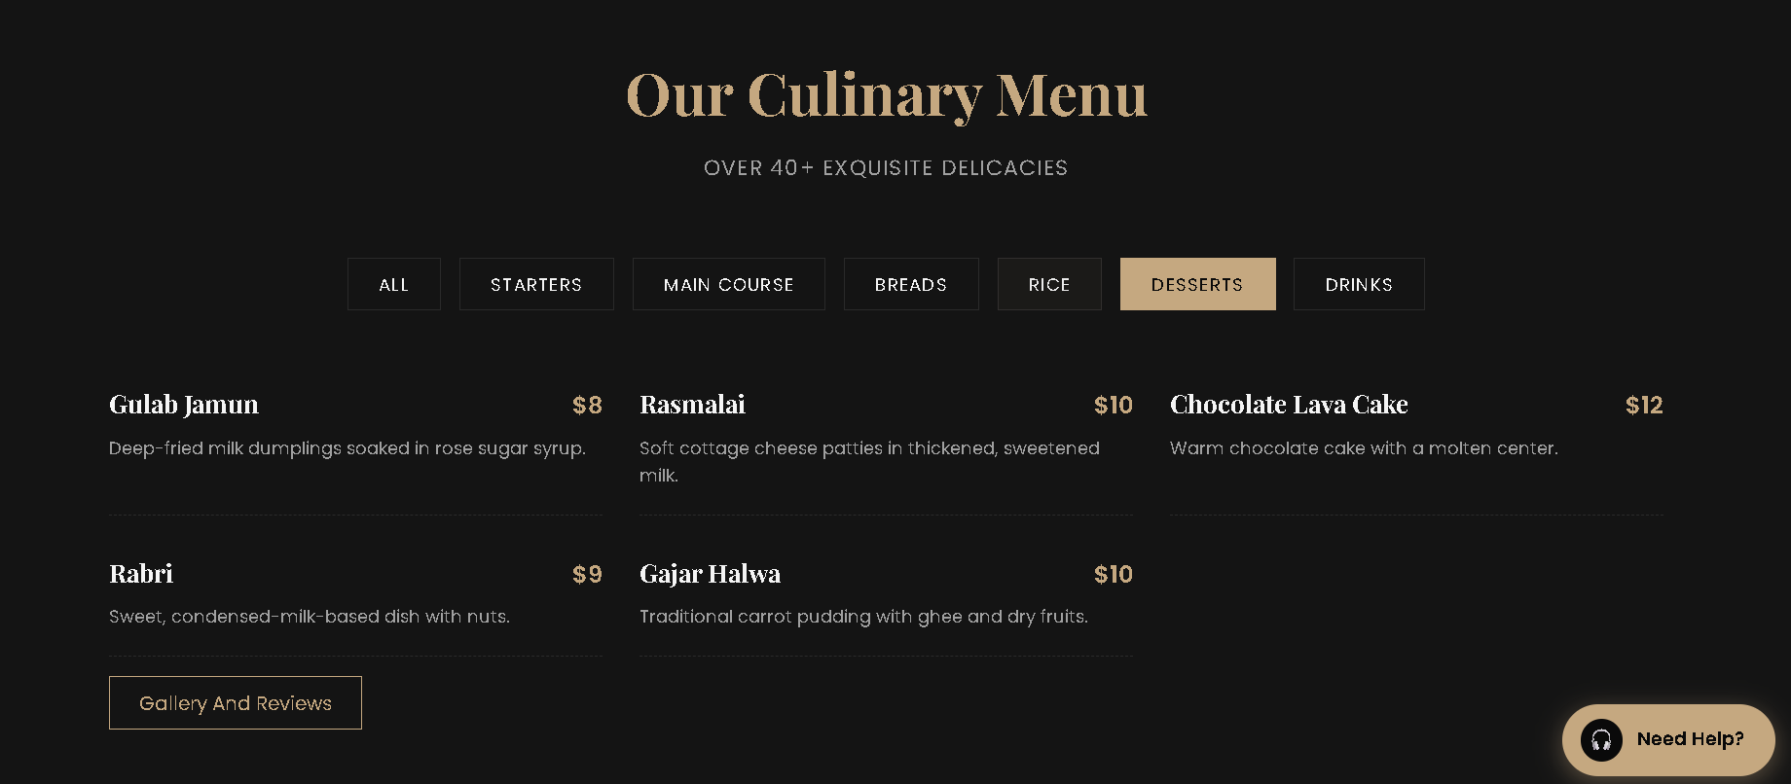
Figure 4: Menu filtering functionality.
I also contributed to app.js, which handles several common interactive features across the website.
The file initialises the AOS animation library when it is available. It also contains live table-stat functionality that retrieves booking statistics through the shared Storage object when that function is available.
Another important feature is the navigation behaviour. When the user scrolls beyond a specific point, the navigation background and shadow are changed. The script also checks the position of page sections and updates the active navigation link according to the section currently being viewed.
I implemented the mobile navigation toggle as well. When the menu button is clicked, the navigation receives or loses its active class and the Font Awesome icon changes between the menu and close icons.
The same file contains the frontend AI receptionist integration. The chat interface is generated dynamically using JavaScript and inserted into the page. Users can open and close the chat interface, enter messages and send them to the configured chat endpoint. A temporary typing indicator is shown while the request is processed, and a fallback response is displayed if the request fails.

Description of Admin Dashboard Code
A major part of my contribution was the Staff/Admin Dashboard, which consists of admin.html, admin.css and dashboard.js.
The admin.html file defines the dashboard structure. It contains a fixed sidebar, a manager header, four reservation statistics cards, a search field, a status filter, an Export CSV button and a reservation table.
The dashboard displays Total Reservations, Guests Today, Completed and Cancelled values. The reservation table contains columns for booking ID, customer, date and time, number of guests, occasion, status and actions.
The page uses jQuery and the project’s shared utils.js and storage.js files. This allows my dashboard code to reuse the existing reservation data and date/time formatting functionality developed as part of the group project.
The visual presentation of the dashboard is controlled by admin.css. I used CSS Grid for the statistics cards and created responsive layouts for different screen sizes. The reservation table is placed inside a horizontally scrollable container on smaller screens so that the columns do not become excessively compressed. Different booking statuses are also visually represented using status badges.
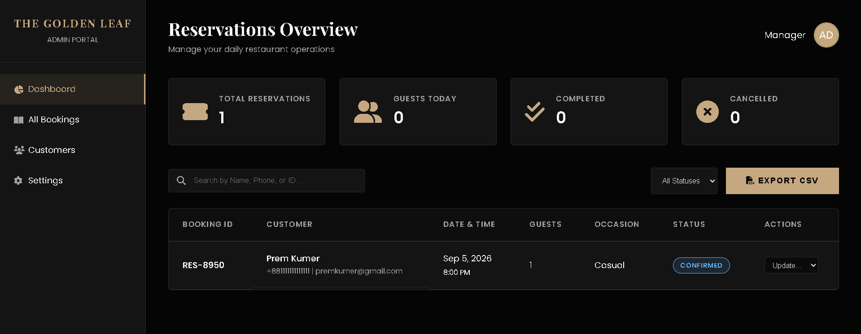
Figure 5: Staff/Admin Dashboard interface.

jQuery Dashboard Functionality
The interactive behaviour of the dashboard is implemented in dashboard.js using jQuery.
When the dashboard loads, the script obtains the booking information using Storage.getAllBookings(). The renderStats() function calculates the current statistics. It counts the total reservations, calculates the number of guests for the current date while excluding cancelled bookings, and counts completed and cancelled reservations.
The renderTable() function dynamically creates table rows from the booking data. Each row displays the customer’s details, formatted booking date and time, number of guests, occasion and current status. The latest records are displayed first.
I also implemented reservation searching and filtering. The search field checks the customer’s name, telephone number and booking ID. The status dropdown allows the user to restrict the table to statuses such as Confirmed, Pending, Completed or Cancelled.
The dashboard also provides status management. When a staff member selects a new status, the corresponding booking is located in the booking array, updated and saved back to local storage. The table is then rendered again so that the updated status becomes immediately visible.
Finally, I implemented CSV export. The JavaScript creates CSV headers, converts the booking records into CSV rows and creates a browser Blob. A temporary download link is generated so the reservation information can be downloaded as a CSV file.
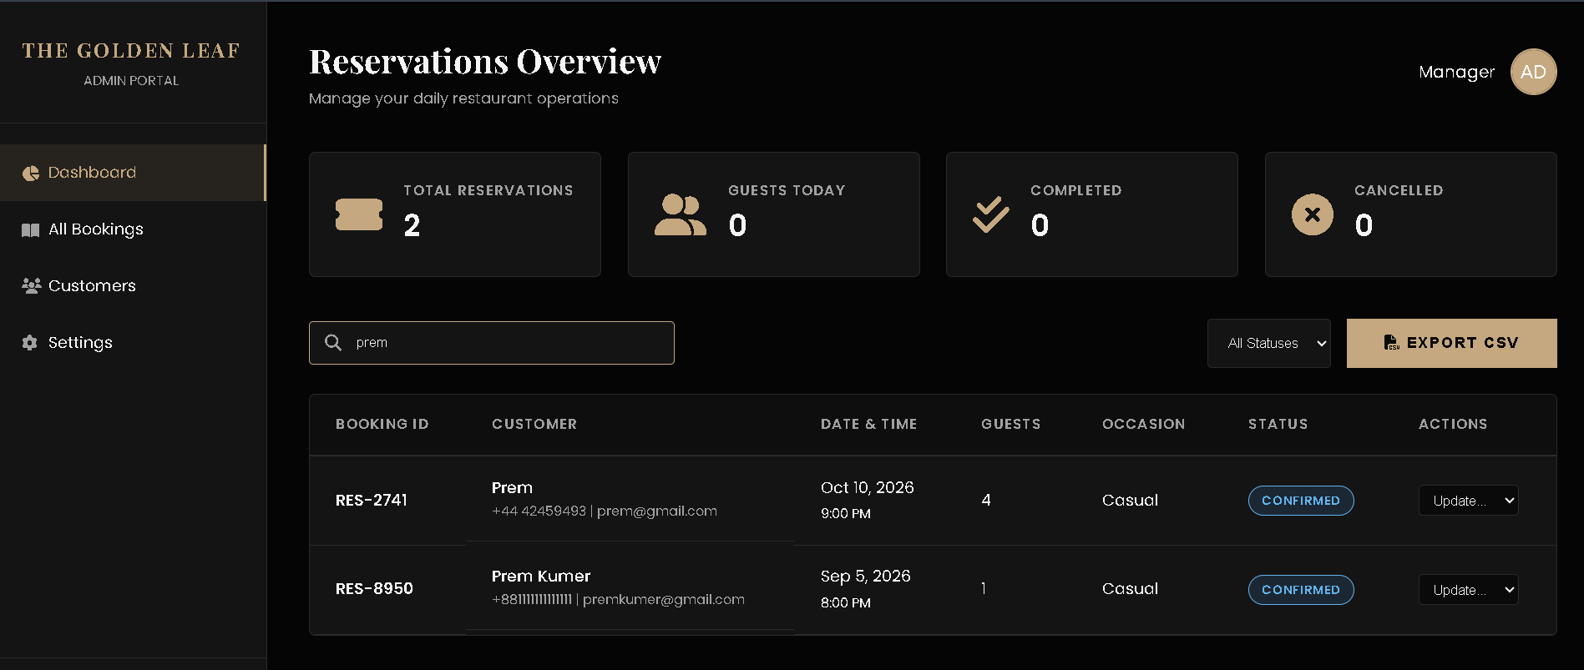
Figure 6: Dashboard search and status filtering.

Testing and Validation
I tested the main features of my work to ensure they functioned correctly. For the Menu page, I checked menu loading, category filtering, active buttons, and layout. For the Admin Dashboard, I tested booking display, search, status filtering, status updates, and CSV export, including the empty-data case. I also tested the website on smaller screen sizes to ensure the menu, navigation, mobile menu, and dashboard remained usable. Any issues found during testing were fixed through further development and Git commits.

Conclusion
My contribution to The Golden Leaf Restaurant Website concentrated on interactive frontend development and reservation management functionality. I developed the Chef and Menu page using HTML and CSS and created the dynamic menu system using JavaScript. The category filtering feature allows users to view selected food groups without requiring separate pages.
I also developed the Staff/Admin Dashboard using HTML, CSS and jQuery. This component provides reservation statistics, dynamic booking records, search and status filtering, booking status management and CSV export functionality. These features provide a practical interface for managing the reservation information collected by the wider project.
In addition, my work on app.js contributed to the website’s common interactions, including AOS initialisation, navigation behaviour, mobile navigation and the frontend AI receptionist interface.
In the process of the project, I had a chance to improve my skills in JavaScript DOM manipulation, jQuery event handling, and responsive CSS, with learning more about client-side data handling and collaborative Git development. Thanks to my contribution, the website was enriched not only for static restaurant details but also featured interactive elements for the customers and an administrator control panel.

